***ASSIGNMENT – 5***

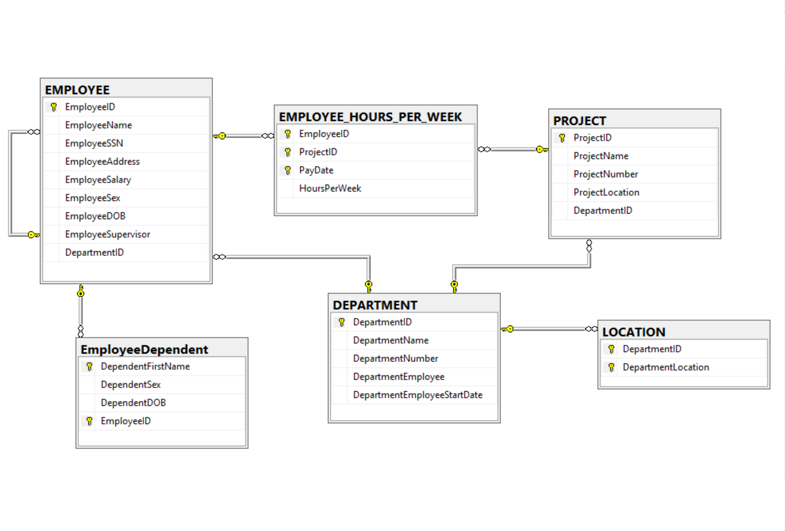

* **TABLES**

DEPARTMENT

PROJECT

LOCATION

EMPLOYEE

EmployeeDependent

EMPLOYEE_HOURS_PER_WEEK

* **PRIMARY KEYS**

DepartmentID in table DEPARTMENT

ProjectID in table PROJECT

(DepartmentID, DepartmentLocation) in table LOCATION

EmployeeID in table EMPLOYEE

(EmployeeID, ProjectID, PayDate) in table EMPLOYEE_HOURS_PER_WEEK

(DependentFirstName, EmployeeID) in table EmployeeDependent

* **FOREIGN KEYS**

EmployeeSupervisor in table EMPLOYEE

DepartmentID in table LOCATION

EmployeeID and ProjectID in table EMPLOYEE_HOURS_PER_WEEK

EmployeeID in table EmployeeDependent

* **COLUMN PROPERTIES**

1. DEPARTMENT TABLE

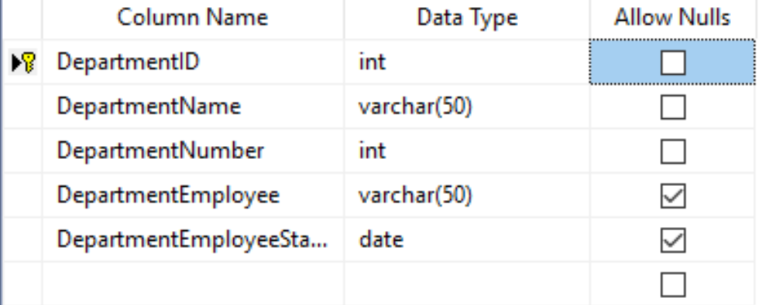

1. PROJECT TABLE

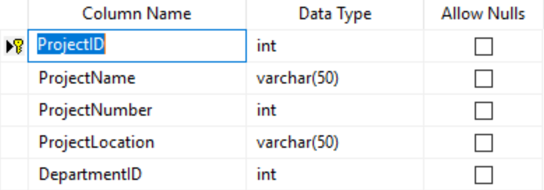

1. EMPLOYEE TABLE

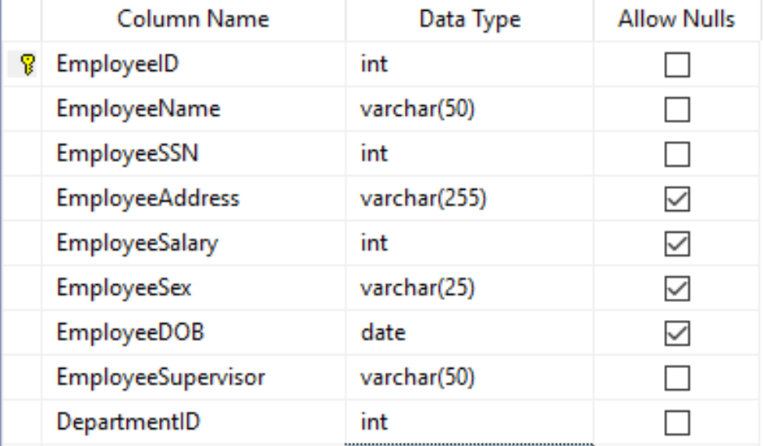

1. LOCATION TABLE

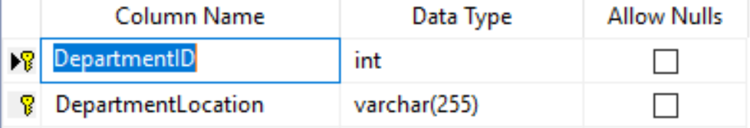

1. Employee_Dependent

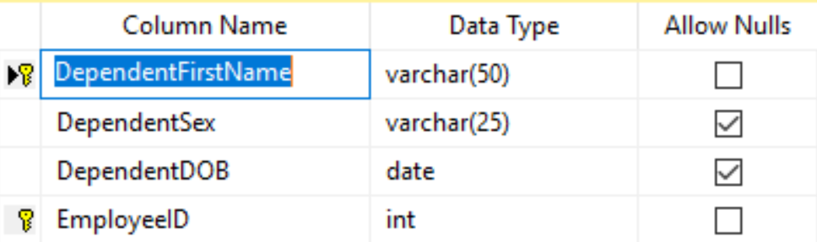

1. EMPLOYEE_HOURS_PER_WEEK

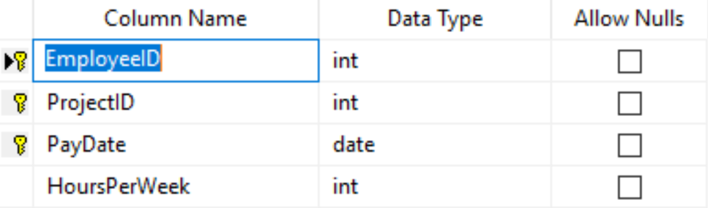

1. **WEAK ENTITIES REPRESENTATION**

The weak entities are EMPLOYEE_HOURS_PER_WEEK, LOCATION and EmployeeDependent.

In the database model, EMPLOYEE_HOURS_PER_WEEK table includes the EmployeeID and ProjectID as the primary keys. EmployeeID and ProjectID are primary keys of table EMPLOYEE and PROJECT respectively.

In the database model, LOCATION table has DepartmentID and DepartmentLocation as the primary keys. EmployeeDependent table has DependentFirstname and EmployeeID as primary keys. DepartmentID and EmployeeID and also foreign keys of tables LOCATION and EmployeeDependent respectively. DepartmentID and EmployeeID are primary keys of the table DEPARTMENT and EMPLOYEE respectively.

So, we created Referential Integrity Constraint between tables EMPLOYEE and EMPLOYEE_HOURS_PER_WEEK, DEPARTMENT and LOCATION, EMPLOYEE and EmployeeDependent. That’s how we represented weak entities.

1. **SUBTYPES AND SUPERTYPES ENTITIES**

There are no supertypes and subtypes entities in this database design.

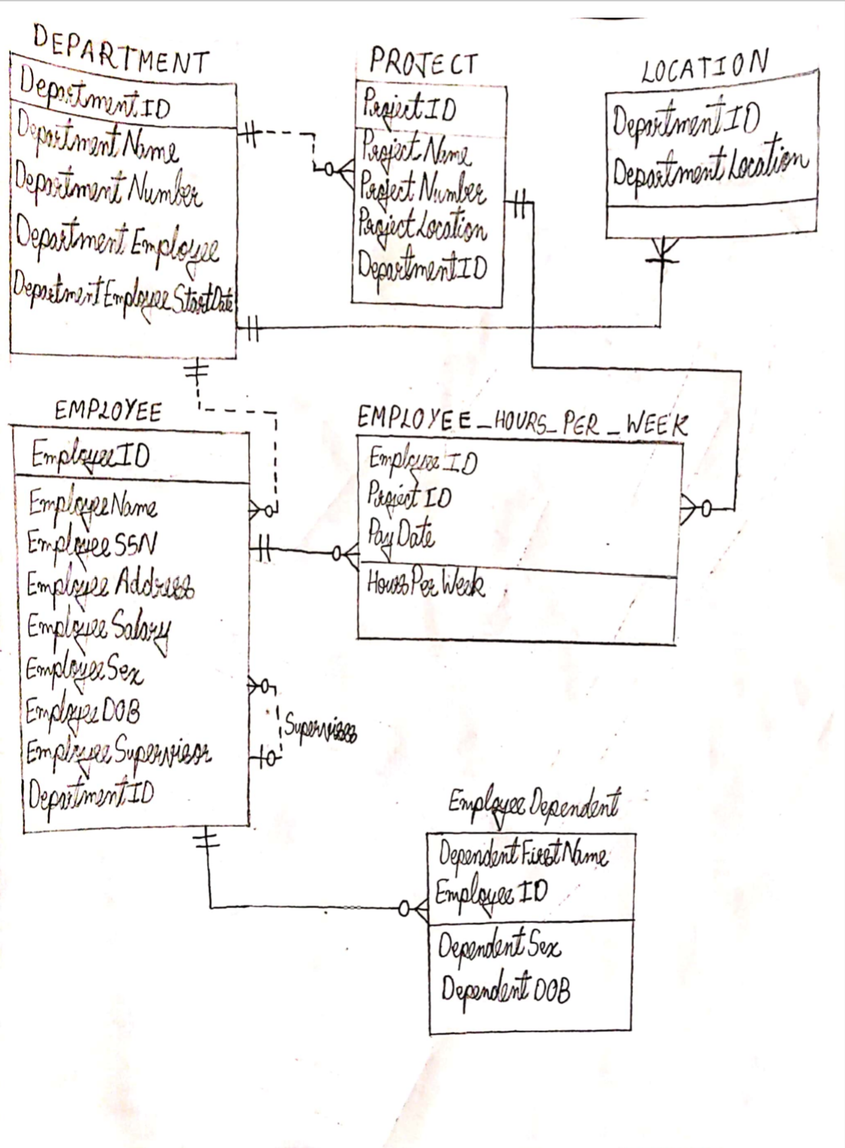

|  |  |  |
| --- | --- | --- |
| RELATIONSHIP | | REFERENTIAL INTEGRITY CONSTRAINT |
| **PARENT** | **CHILD** |  |
| DEPARTMENT | PROJECT | DepartmentID in PROJECT table must exist in DEPARTMENT table. |
| DEPARTMENT | LOCATION | DepartmentID in LOCATION table must exist in DEPARTMENT table. |
| DEPARTMENT | EMPLOYEE | DepartmentID in EMPLOYEE table must exist in DEPARTMENT table. |
| PROJECT | EMPLOYEE_HOURS_PER_WEEK | ProjectID in EMPLOYEE_HOURS_PER_WEEK table must exist in PROJECT table. |
| EMPLOYEE | EMPLOYEE | EmployeeSupervisor in EMPLOYEE table relates to EmployeeName in EMPLOYEE table. |
| EMPLOYEE | EmployeeDependent | EmployeeID in EmployeeDependent table must relate to EMPLOYEE table. |
| EMPLOYEE | EMPLOYEE_HOURS_PER_WEEK | EmployeeID in EMPLOYEE_HOURS_PER_WEEK table must relate to EMPLOYEE table. |